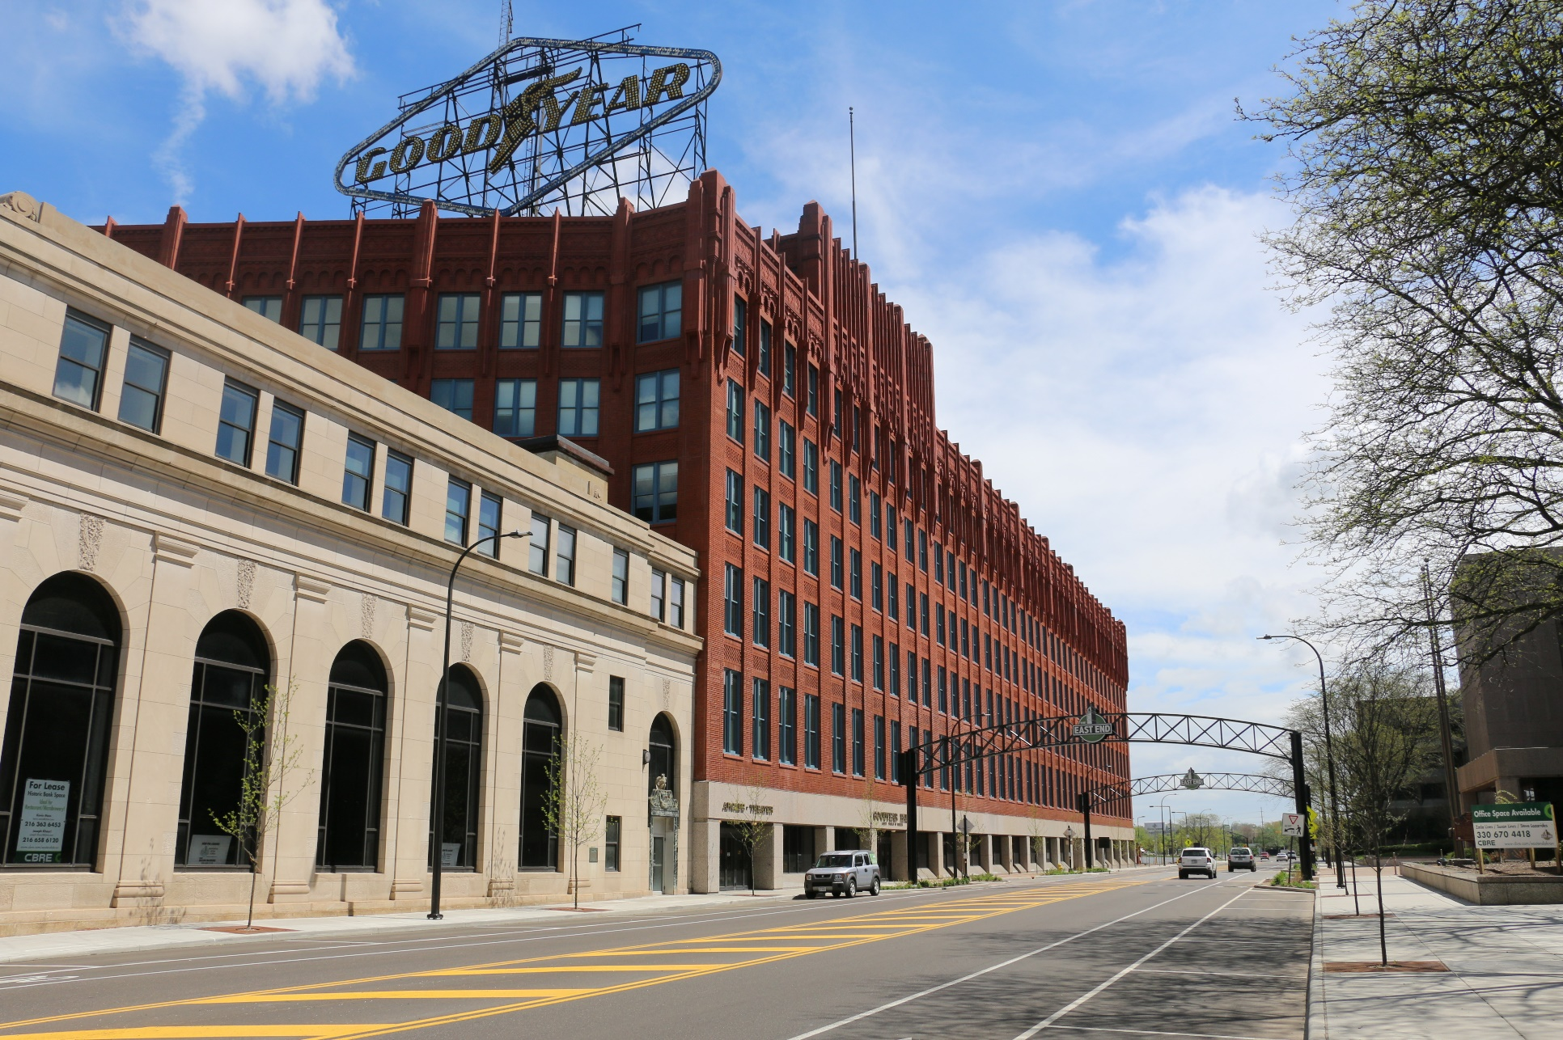

**December**

Newsletter

|  |  |
| --- | --- |
| ***East End Happenings***   * **Eighty-Three Brewery** will be offering their Barrel Aged Christmas Ale and limited-edition glassware. <https://www.eighty-threebrewery.com/> * L**aBelle’s Barber** offers online reservations [labelles.resurva.com/book](https://labelles.resurva.com/book). * **Marques Restaurant** is Akron’s finest southern cuisine. Dine in or cater your next event. <https://marqueseastend.com/> * **Handel’s Ice Cream’s** flavors of the month are Peppermint Stick, Peppermint Bark, Egg Nog, and Cherry Cordial. * **Pita Pit** Stop in and try one of their awesome pitas. * **Starbucks** will be donating a meal to Feeding America for every protein Box they sell until January 1st. * Goodyear Library Newsletter<https://www.flipsnack.com/ACF6AEEEFB5/goodyear-branch-library-winter-2024-25/full-view.html>   **Holiday Hours**  Starbucks will be closed on  December 25th and January 1st. They will also close early at 2pm on December 24th and December 31st.  Eighty-Three Brewery will Closed December 24th & 25th and also December 31st and January 1st.  Wishing everyone a safe and Happy Holiday Season! | Hours of Operation:   * East End Café: Monday – Thursday 8am – 10am for Breakfast and Lunch from 11 am – 1:30 pm * East End Café Bar: Thursday 4 - 7 pm * Goodyear Theater Box Office: Monday - Friday 10 am – 4 pm * Starbucks Coffee: Daily 6 am – 6 pm * Pita Pit: Monday – Saturday 10:30 am – 9 pm; Sunday 11 am – 8 pm * Handel’s Ice Cream: Daily 11 am – 10 pm * Marques: Tuesday – Thursday 11 am - 8 pm; Friday - Saturday 11 am – 9 pm; Sunday noon -5 pm * 83 Brewery: Tuesday – Thursday 3:30 pm -10 pm; Friday 11:30 am – 11 pm; Saturday 12 pm – 11 pm; Sunday 12 pm – 7 pm   Can |

|  |  |  |
| --- | --- | --- |
|  |  |  |

***Goodyear Theater Calendar***

Thursday, December 5 – Twas a Girls Night Before Christmas

Friday, December 6 – Summit Choral

Saturday, December 7 – Coop’s Nightmare

Friday, December 13 – A Magical Motown Christmas

Saturday, December 14 – O’ Christmas Tree

Saturday, December 21 – One Silent Night

Purchase Tickets:

[www.goodyeartheater.com/page/view-all-shows](http://www.goodyeartheater.com/page/view-all-shows)

## 330-659-7118

## 1201 East Market St., Akron, OH, 44305 [www.eastendakron.com](http://www.eastendakron.com)